|  |  |
| --- | --- |
| Name: Dayem Mujahid | EE-272L Digital Systems Design |
| Reg. No.: 2023_EE_072 | Marks Obtained: ____________ |

**Lab Manual**

**Experiment 1**

**MOSFET as an inverter**

|  |  |  |  |  |  |
| --- | --- | --- | --- | --- | --- |
| **DSD Lab Manual Evaluation Rubrics** | | | | | |
|  |  |  |  |  |  |
| **Assessment** | **Total Marks** | **Marks Obtained** | **0-30%** | **30-60%** | **70-100%** |
| Code Organization (CLO1) | 3 |  | No Proper Indentation and descriptive naming, no code organization.  Zero to Some understanding but not working | Proper Indentation or descriptive naming or code organization.  Mild to Complete understanding but not working | Proper Indentation and descriptive naming, code organization.  Complete understanding, and proper working |
| Simulation (CLO2) | 5 |  | Simulation not done or incorrect, without any understanding of waveforms | Working simulation with errors, don't cares's(x) and high impedance(z), partial understanding of waveforms | Working simulation without any errors, etc and complete understanding of waveforms |
| FPGA (CLO2) | 2 |  | Not implemented on FPGA and questions related to synthesis and implementation not answered. | Correctly Implemented on FPGA or questions related to synthesis and implementation answered. | Correctly Implemented on FPGA and questions related to synthesis and implementation answered. |

**Experiment 1**

1. The answers to the questions given in Section 1.
2. Apply 5V at terminal A, what is the voltage at terminal B? Does the LED glow?

No, the LED doesn’t glow then 5V is applied to terminal A. The voltage at terminal B is 0V.

1. Apply 0V at terminal A, what is the voltage at terminal B? Does the LED glow?

Yes the LED glows when 0V is applied to terminal A , The voltage as terminal B is 1.9V

1. Apply a 1 kHz, 5V peak voltage square wave at terminal A using the signal generator. Plot the input voltage at terminal A and the output voltage at terminal B using C.R.O. When the input goes from high voltage to low voltage, how much time does the output take to go from low voltage to high voltage (propagation delay)? Similarly, find the time the output takes to go from high to low voltage.

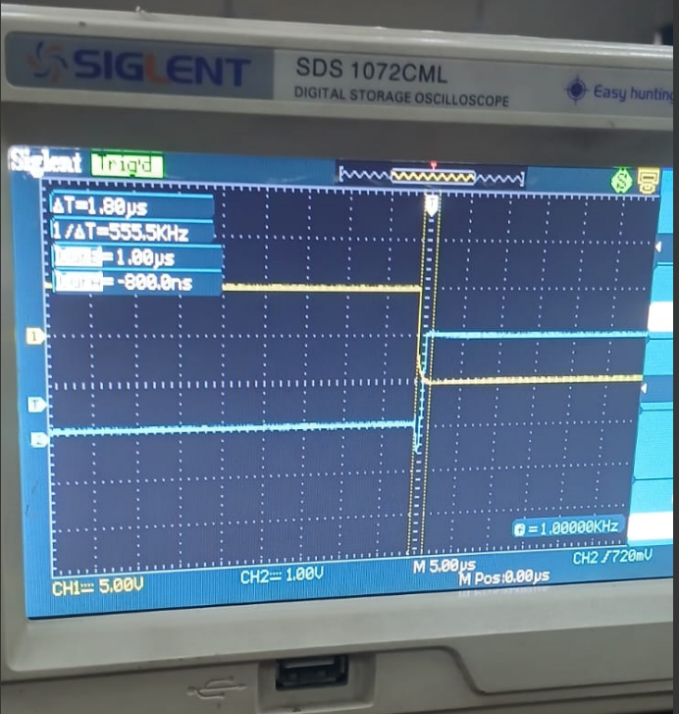

When the output take to go from low voltage to high voltage the propogation delay is 1.8us.

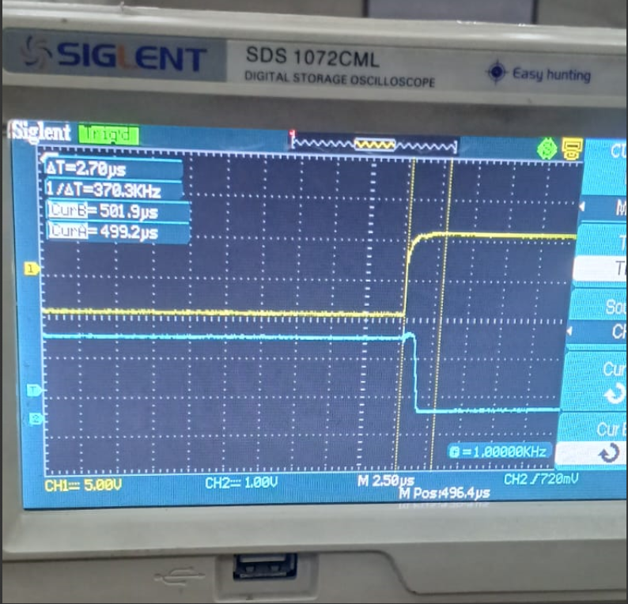

.

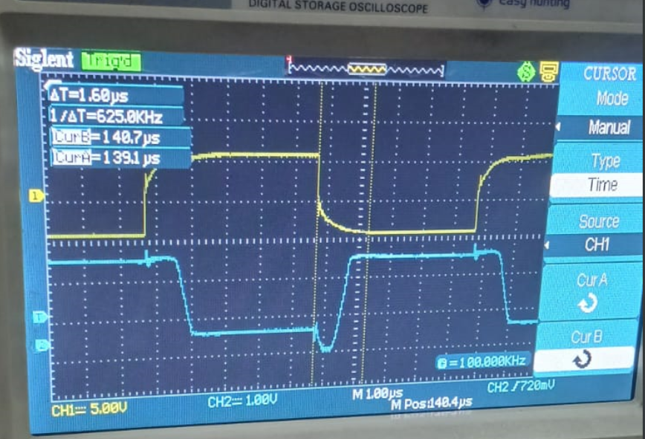When the output takes to go from High voltage to low voltage the propagation delay is 2.7us.

1. Repeat the above step by applying the frequency of 100kHz at the input terminal

When the output take to go from low voltage to high voltage the propogation delay is 1.6us.

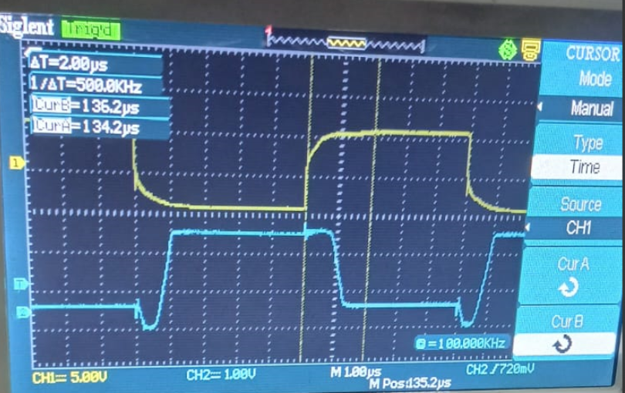

When the output take to go from high voltage to low voltage the propagation delay is 2us.

1. How does the change of frequency affect the mode of operation of a transistor?

As the frequency increases, the input signal changes between high and low more quickly.

1. **Unstable Output:** The transistor may not fully switch before the next change, making the output incomplete or distorted(noise).
2. **Increased Delay:** The transistor needs time to switch states, and at high frequencies, the next change may start before the previous one is complete, causing increased propagation delays.

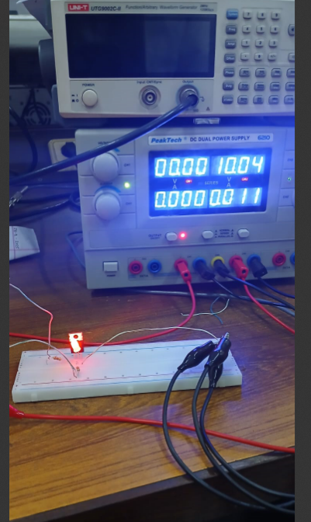Appendix:

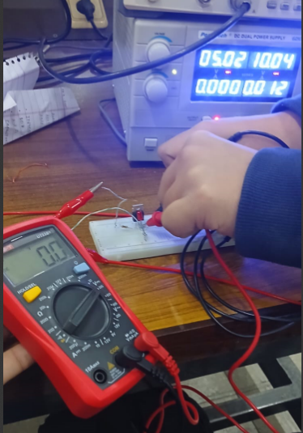

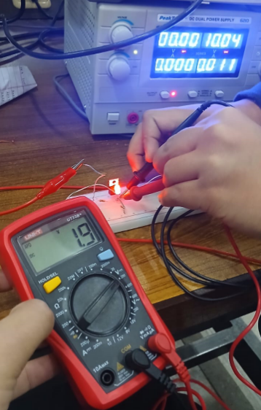Fig:LED glowing at 0V Fig: Voltage at B when VA=5.02V

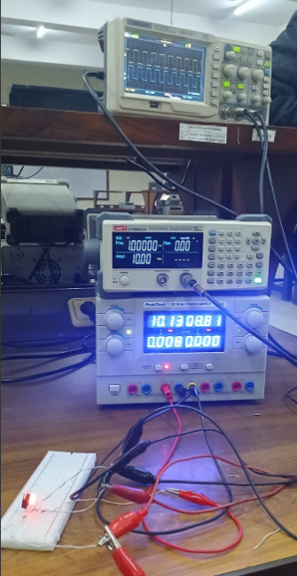

Fig:Voltage at B when VA=1.9V Fig:Circuit for part c